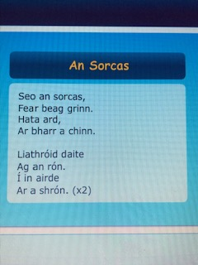

Léigh an dán. (Read the poem)
Tarring pictiúr faoin dán. (Draw a picture about the poem)

sorcas – circus
fear grin – clown
liathróid daite – coloured ball
rón - seal

