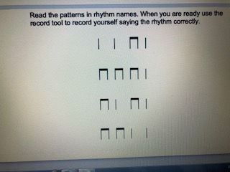

Complete each line using Ta or ti-ti
Line 1 – Ta Ta ti-ti Ta

Line 2 –

Line 3 –

Line 4 -

