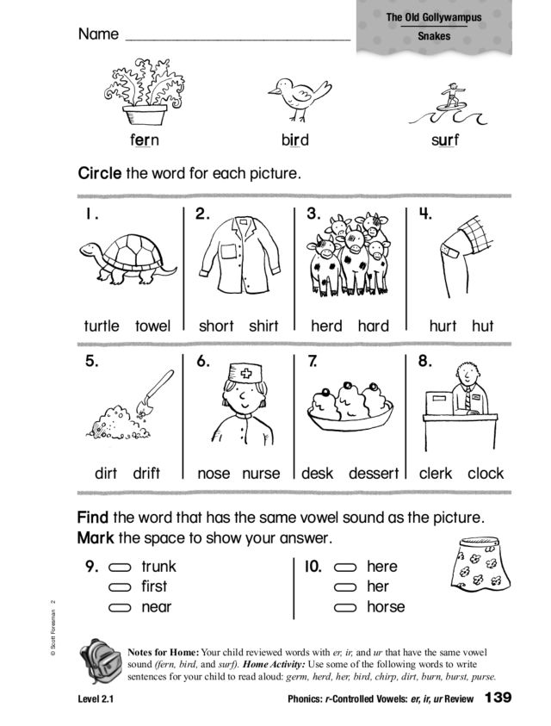
Write a sentence with a words with er, ir or ur in it.

